Clinical Supervision Guidelines
Enhanced Maternal and Child Health Program
OFFICIAL

Clinical Supervision Guidelines
Enhanced Maternal and Child Health Program

To receive this document in another format, email MCH@health.vic.gov.au <mch@health.vic.gov.au>.
Authorised and published by the Victorian Government, 1 Treasury Place, Melbourne.
© State of Victoria, Australia, Department of Health, January 2024.
Except where otherwise indicated, the images in this document show models and illustrative settings only, and do not necessarily depict actual services, facilities or recipients of services. This document may contain images of deceased Aboriginal and Torres Strait Islander peoples.
In this document, ‘Aboriginal’ refers to both Aboriginal and Torres Strait Islander people. ‘Indigenous’ or ‘Koori/Koorie’ is retained when part of the title of a report, program or quotation.
ISBN 978-1-76069-963-5
Available from the Maternal and Child Health Service Framework page on the Health.vic website <https://www.health.vic.gov.au/maternal-child-health/maternal-and-child-health-service-framework>

Contents
Purpose of the clinical supervision guidelines 6
A note on the reissued version 6
Background 6
Audience 7
Outcomes 7
Principles of clinical supervision 7
Defining clinical supervision 8
Models of clinical supervision 8
Types of supervision 9
Limitations of clinical supervision 10
Clinical supervision modalities 11
Recommended best practice principles 11
Partnering 12
Roles and responsibilities 12
Role of the supervisor 12
Role of the supervisee 12
Role of the MCH Coordinator 13
Clinical supervision agreements 13
Confidentiality 14
Reflective practice during clinical supervision 14
Clinical supervision competency 15
Monitoring and evaluation 16
References 17
Appendix 1: Clinical supervision agreement example 19
Signatures 21
Appendix 2: Example of clinical supervision session feedback template 22
Appendix 3: Clinical supervision quarterly evaluation example 23
Appendix 4: Clinical supervision group attendance record example 25
Storage: 25

Purpose of the clinical supervision guidelines
The purpose of the Clinical supervision guidelines for enhanced maternal and child health program is for the Department of Health (department), to provide:
- a clear definition of clinical supervision and the use of reflective practice for Enhanced Maternal and Child Health (MCH) nurses
- best practice guidance on the provision of clinical supervision, taking into consideration various demographics.

A note on the reissued version
Due to machinery of government changes, this document was reissued in 2019 and 2023 without extensive revision to meet accessibility requirements. While the content is still relevant, some references to departments, agencies and other publications may be out of date.

Background
Victoria’s Education State Early Childhood Development Reform Plan (2017/18) outlined Victoria’s commitment to providing higher quality services and to reduce disadvantage in the early years of childhood. In support of this vision, the department has strengthened the MCH Service though a number of reform initiatives. It included the expansion of the Enhanced MCH Program to ensure that the increasing number of families with additional needs presenting to MCH are well supported.
The commitment to expand the Enhanced MCH Program was a key finding of commissioned reports undertaken for the department. Additionally, these reports identified an opportunity to further increase the capability and confidence of the Enhanced MCH workforce through the provision of structured clinical supervision, utilising reflective practice.
Clinical supervision has been promoted as an important strategy to support all nurses, as well as a process to enhance patient care and promote ongoing professional development (Brunero & Stein- Parbury, 2008).
Effective clinical supervision utilising reflective practice allows practitioners to apply knowledge and to increase skills, which leads to better practice, reduced burnout and lowers staff turnover (Tomlin and Scott Heller 2016). According to Brunero and Stein-Parbury (2008) clinical supervision provides peer support and stress relief for nurses (restorative function), a means of promoting professional accountability (normative function) and skill and knowledge development (formative function).
Nationally, reflective practice is recommended under the Nursing and Midwifery Board of Australia’s Registered Nurse Standards for Practice (2016) and the National Competency Standards for the Midwife (2006). Clinical supervision is encouraged across Australian jurisdictions through the National Framework for Universal Child and Family Health Services (Australian Health Ministers' Advisory Council 2011), and by the nursing profession through the National Standards of Practice for Maternal, Child and Family Health Nurses in Australia (Grant et al. 2017).

Audience
The Clinical Supervision Guidelines have been developed for use by the following individuals to describe and improve the standards and consistency of clinical supervision for the Enhanced MCH workforce working in MCH services across Victoria:
- MCH service organisations’ chief executives and management
- MCH Coordinators and team leaders
- Enhanced MCH nurses.
These guidelines have been developed for Enhanced MCH nurses. However, the Enhanced MCH workforce in some MCH services also includes allied health professionals who complement the Enhanced MCH nurses. The allied health staff may be participating in their own, or workplace provided, clinical supervision due to professional registration requirements or voluntarily for professional development, safety and wellbeing benefits.

Outcomes
The overall purpose of clinical supervision is to provide the best available standard of care. In a relationship based on trust and openness, clinical supervision provides the opportunity for supervisees to review and reflect on their work to be able to improve in the future (Carroll cited in Health Education and Training Institute 2013).
According to Driscoll (cited in Health Education and Training Institute 2013) the benefits of regular clinical supervision include:
- increased feelings of support, job satisfaction and morale
- promotion of work-based learning and the development of new skills
- increased professional discipline, growth and identity
- improved recruitment and retention of staff
- beneficial risk management strategy for organisations
- promotion of quality assurance and competent best practice
- reductions in professional isolation, levels of stress, emotional exhaustion and burnout.

Principles of clinical supervision
The principles of clinical supervision to ensure effectiveness are as follows.
Clinical supervision:
- is dedicated and protected time set aside for facilitated in-depth reflection on clinical practice
- is a means of supporting Enhanced MCH nurses in the provision of safe and effective care
- supports the effective processing of emotional reactions by the Enhanced MCH nurse occurring during clinical practice
- is the shared responsibility of MCH service management (MCH Coordinator or equivalent) and the Enhanced MCH nurse
- is guided by a confidentiality agreement between the supervisor and supervisee/s.

Defining clinical supervision
The term clinical supervision is used in a variety of ways to describe dedicated time to reflect on clinical practice and situations that occur in the context of the work environment. No single definition fits all models and professions. The following definitions of clinical supervision were identified in a literature review.
Clinical supervision is “regular, protected time for facilitated, in-depth reflection on clinical practice”. (Bond and Holland 1998).
“Clinical supervision is a formal process for reflection on practice with the aim of improved outcomes for the clients as well as support and professional development for the child and family health nurse.” (Child and Family Health Nurses Association (NSW) Inc. 2003).
“A process within which the clinician brings his or her practice under scrutiny in order to more fully appreciate the meaning of their experience, to develop their abilities, to maintain standards of practice and to provide a more therapeutic service to the client.” (Consedine 2001).
“The provision of empathetic support to improve therapeutic skills, the transmission of knowledge, and the facilitation of reflective practice. This process seeks to create an environment in which the participants have an opportunity to evaluate, reflect and develop their own clinical practice and provide support for one another” (Winstanley and White 2003).
Although there are differences in these definitions, they share a similarity of clinical supervision being protected time set aside for facilitated support.
The goal of clinical supervision is to develop and/or maintain a nurse’s professional functioning while safeguarding the client’s care to ensure a consistent quality service. It enables nurses to discuss a broad range of issues related to client care in a supportive environment (Children’s Health Queensland Hospital and Health Service, 2015).
Clinical supervision is a working alliance between a supervisor and the Enhanced MCH nurse/s (supervisee/s) that takes place in planned, regular meetings during which the supervisee has the opportunity to give an account of their work, review and reflect on their practice and to develop their professional identity. The object of the supervisory relationship is to support the supervisee to utilise evidence-based practice and to maintain competency, confidence and creativity in order to give the best possible service to clients (Eastern Health 2017).

Models of clinical supervision
There are different models of clinical supervision, reflecting the differing work context and the professional training needs and expectations of staff, and there is no one model of supervision that will suit all occasions (Health Education and Training Institute 2015). Some recognised models of clinical supervision are:
- Growth and Support Model (Butterworth and Faugier 1992)
- Integrative approach (Hawkins and Shohet 1989)
- Role Development Model (Consedine 2001)
- Three-Function Interactive Framework of Supervision (Proctor 1987).
In the Growth and Support Model, the role of the supervisor is to facilitate growth both educationally and personally in the supervisee, while providing essential support to their developing clinical autonomy (Butterworth and Faugier 1992).
The Integrative Approach looks closely at the process of the supervisory relationship across four components (supervisor, supervisee, client and work context) in the therapy system and the supervision system (Hawkins and Shohet 1989).
The Role Development Model is a person-centred model, with the supervisor facilitating the supervisee’s journey as they consider new ways of viewing a situation. The supervisor may not be an expert in the supervisee’s field of practice but is trained in the art and skill of clinical supervision.
As identified in the Three-Function Interactive Framework of Supervision of Proctor (see Figure 1), supervision commences with an educative activity (formative function) as the basis for clinical supervision and enables the development of a consistent approach to patient care (normative function), while promoting validation and support through peer feedback (restorative function).
These three functions of Proctor’s model of clinical supervision are highlighted by Brunero & Stein- Padbury (2008) as follows:
- formative: to increase skills and knowledge
- normative: to enhance professional accountability
- restorative: to facilitate collegial and supportive relationships.
Figure 1: Proctor’s model of supervision
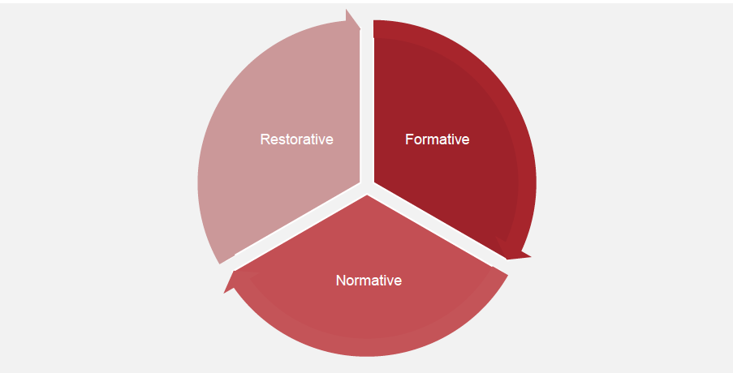
Of all the models of supervision, Proctor’s Model of Supervision has become one of the most widely adopted models in nursing contexts (Australian College of Nursing 2016).

Types of supervision
Operational supervision is essential for the provision of safe person-centred health care. There are many operational processes that MCH Coordinators (or equivalent) engage as part of their line management responsibilities, such as the monitoring of performance, development plans and case reviews. It is important to note that clinical supervision is distinctly different from operational supervision, as outlined by the Australian Clinical Supervision Association (2015). A modified diagram is displayed below in Figure 2.

Figure 2: Operational supervision vs clinical supervision
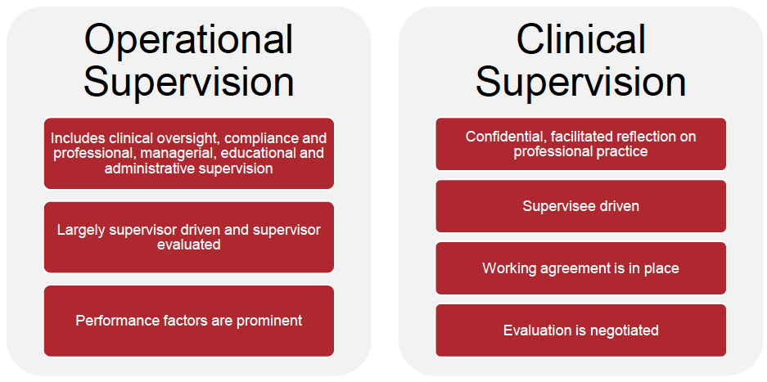

As clinical supervision is a professional process, any operational, management or personal issues are not appropriate for discussion. There may be times where a professional or clinical issue is actually a management issue. In this instance, the Clinical Supervisor facilitating the session will ask the group member to discuss the issue with their line manager.
Common situations that Enhanced MCH nurses may bring to clinical supervision include:
- interactions with clients and their family
- interactions with colleagues
- distressing or traumatic experiences in the workplace
- experiences of working with organisational systems
- professional development opportunities.

Limitations of clinical supervision
Clinical supervision is not:
- the oversight of clinical work by line management
- individual performance review or a form of disciplinary procedure
- preceptorship or mentoring
- critical incident debriefing
- psychotherapy or counselling
- a forum for personal, professional or organisational grievances.

Clinical supervision modalities
Individual: this involves a supervisor providing clinical supervision for a single supervisee. In this arrangement, the context and process are tailored to the needs of the supervisee and documented in the clinical supervision agreement. Individual supervision may be undertaken by a trained supervisor from within the organisation who is not the direct line manager, or through an external supervisor with recognised training and experience. The clinical supervisor must meet the National Clinical Supervision Competency (Health Workforce Australia 2014). Individual supervision has the added benefit of allowing the supervisory relationship to develop more quickly and may allow for more in depth reflection. However, the supervisee only gets a single perspective of an issue.
Group Supervision: this takes place where a group of between four to six participants join for supervision by a trained clinical supervisor. The clinical supervisor could be from within the MCH workforce or another discipline such as Allied Health or Psychology and must meet the National Clinical Supervision Competency (Health Workforce Australia 2014). In a group setting, the clinical supervisor must have the attributes and skills to facilitate groups. The group participants may be only Enhanced MCH nurses from one or more local governments or mixed with either other members of the MCH workforce or other health professionals. The group may identify a specific developmental need or perspective which is supported by the external supervisor. The MCH Coordinator (or equivalent) endorses the group composition and jointly identifies a supervisor with the supervisees. The benefits of group clinical supervision are: removing isolation, shared learning and developing a closer network of support, potentially across a multi-disciplinary setting. The goals and objectives of supervision are agreed by the group and the supervisor and documented in the clinical supervision agreement.

Recommended best practice principles
To ensure the safety and wellbeing of staff and the provision of a quality and responsive service, the following standards of best practice are applicable for Enhanced MCH nurse clinical supervision. Clinical supervision:
- is offered to all Enhanced MCH nurses including casual and relief staff
- occurs monthly for one hour on a pro-rata basis
- monthly for 0.6 – 1.0 FTE
- bi-monthly for 0.1 – 0.5 FTE
- occurs in groups of four to six or individually in response to an additional need e.g. geographic isolation, ongoing challenge or risk of vicarious trauma
- may be delivered flexibly to meet the needs of the MCH service e.g. in conjunction with other training or accumulated to allow longer sessions
- is scheduled into the diary of the Enhanced MCH nurse
- is provided by a supervisor who has attended training in clinical supervision and who receives clinical supervision themselves
- is structured, guided by the supervisor who is not a direct line manager
- is confidential, with the exemptions outlined in the ‘Confidentiality’ section
- is underpinned by a written clinical supervision agreement between the supervisee/s and supervisor including confidentiality exemptions
- is wherever possible, undertaken in person with the option of phone, video or web conferencing in extreme circumstances
- is monitored and evaluated for effectiveness each month and reviewed annually
- is acquitted annually for funding purposes.

Partnering
Where groups of four to six are not possible within an MCH service, MCH Coordinators / Team Leaders could work with neighbouring services to form groups across municipalities. In rural areas where distance is particularly problematic, MCH services could consider partnerships with maternity services, early childhood, community or mental health organisations within the local area.

Roles and responsibilities

Role of the supervisor
The role of the supervisor is to effectively facilitate reflection on the group’s clinical practice in a way that develops their abilities, maintains standards of practice and addresses the identified goals and objectives of the supervisees. The supervisor will work with the individual or group to develop the clinical supervision agreement and engage in supervision as agreed. The supervisor will promote evidence based practice and provide opportunities for skill development.
The clinical supervisor will:
- maintain confidentiality, with agreed exceptions
- create a safe environment for reflection
- monitor the supervisory relationships
- time manage sessions
- maintain records of attendance
- provide a de-identified quarterly summary report to the MCH Coordinator (or equivalent) on key themes and professional development opportunities
- notify the MCH Coordinator with issues relating to exemptions from confidentiality. Should information need to be shared, the supervisor will advise the supervisee in advance, including what will be shared, with whom and for what purpose
- engage in their own clinical supervision.

Role of the supervisee
The role of the supervisee is to identify, in conjunction with the MCH Coordinator, a clinical supervision group to participate in and an individual or external group supervisor. The supervisee will contribute to the development of the clinical supervision agreement and provide feedback to the supervisor at the conclusion of each session.
The supervisee will:
- commit to identifying a suitable supervisor and modality
- actively participate in the session
- prepare for sessions by considering a case, issue or topic which can be explored
- be respectful and supportive of other participants in the group
- maintain confidentiality, discussing with the supervisor any identified confidentiality exemptions
- be willing to learn and change in the process of receiving support and being challenged in their thinking
- take active steps in response to their reflection and learning.

Role of the MCH Coordinator
The role of the MCH Coordinator (or equivalent) is to ensure all Enhanced MCH nurses have access to clinical supervision as scheduled in their diary. The MCH Coordinator will support the identification of available clinical supervision groups for the Enhanced MCH nurse participation and review the clinical supervision arrangements annually. Where individual clinical supervision is required the MCH Coordinator will identify an appropriately trained Clinical Supervisor, in conjunction with the supervisee.
The MCH Coordinator will:
- ensure a local policy is developed to govern the implementation of the clinical supervision guideline within their MCH service setting
- ensure that all Enhanced MCH nurses are familiar with this guideline
- ensure the clinical supervision modality meets the needs of the individual Enhanced MCH nurse
- provide additional professional support or take appropriate action according to the policies and legislative requirements when issues that are exempt from confidentiality are identified and raised by the supervisor.

Clinical supervision agreements
A clinical supervision agreement is to be negotiated in the first supervision session with the group or individual. Both the supervisor and supervisee/s are responsible for negotiating an agreement acceptable to all parties. The agreement should be formalised in writing prior to the second session and include the opportunity for both parties to discuss how the supervisory relationship is going, the need for changes and a review of goals. See Appendix 2 for an example of a clinical supervision agreement.
Clinical supervision agreements might include:
- the agreed purpose and goals for supervision
- the roles and responsibilities of the supervisor and supervisees
- where and when supervision will occur
- arrangements for cancelling or rescheduling supervision
- ethical considerations
- documentation processes
- confidentiality and the process for exemptions to confidentiality. This process might include that the supervisor will advise the supervisee in advance, including what will be shared, with whom and for what purpose.
- the duration, monitoring and evaluation of the agreement
- the process for resolving difficulties in the supervisory relationship
- the process for ending a clinical supervision agreement.

Confidentiality
Clinical supervision is underpinned by confidentiality as the basis for nurses to form open and trusting relationships with their supervisor. It protects client’s personal information, the nurse integrity and any sensitive information that may be raised. As such, how confidentiality will be managed should be expressly discussed with the individual or group at the commencement of the supervisory arrangement, documented in the clinical supervision agreement and strictly adhered to.
Registered nurses and midwives must practice in accordance with the professional Codes, Standards and Guidelines set out by the Nursing and Midwifery Board of Australia. These detail:
- the obligations of registered nurses and midwives to protect the privacy and confidentiality of patients/clients
- the obligations of registered nurses and midwives in regard to making a mandatory notification of a health practitioner’s conduct under the Health Practitioner Regulation National Law (Victoria) Act 2009 (National Law) (Australian Health Practitioner Regulation Agency 2014).
Additionally, the National Law outlines the obligations of employers in regard to making a mandatory notification.
The Clinical Supervision Guidelines expect that registered nurses and midwives, registered health practitioners and employers are aware of and comply with their obligations under the National Law in regard to mandatory notification. These Guidelines do not affect other mandatory reporting requirements of nurses or clinical supervisors that may be established in separate legislation or obligations, for example when there is a risk of harm to self, or risk of harm to mother, parent or infant.

Reflective practice during clinical supervision
Reflective practice is the preferred method used during clinical supervision.
Reflective practice happens when a nurse explores an experience they have had to identify what happened, and what their role in this experience was – including their behaviour and thinking, and related emotions. This allows the nurse to identify changes to their approach for similar future events. Reflective practice can be defined as:
- ‘the ability to reflect on action so as to engage in a process of continuous learning’ (Schön 1983)
- ‘Process of internally examining and exploring an issue of concern, triggered by an experience, which creates and clarifies meaning in terms of self and which results in a changed conceptual perspective’ (Boyd and Fales, 1983, p.100).
There are various models of reflective practice (Latrobe University 2017), such as those developed by:
- Atkins and Murphy
- Gibbs
- Johns
Each of these models guide the conversation from describing the situation to identifying a lesson from the event. One of the most widely used models is Gibbs (see modified version at Figure 4). The reflective cycle enables participants to focus on their and other’s views, perceptions and feelings. It prompts supervisees to think about ‘walking in someone else’s shoes’ and to use empathy as a vehicle for reflection.
The process requires participants to look beneath the surface of events and experiences, to achieve a deeper level of reflection and learning. It involves the deconstructing, unpacking or pulling apart to gain better understanding, seeing connections and appreciating different perspectives.
Figure 3: Reflective cycle
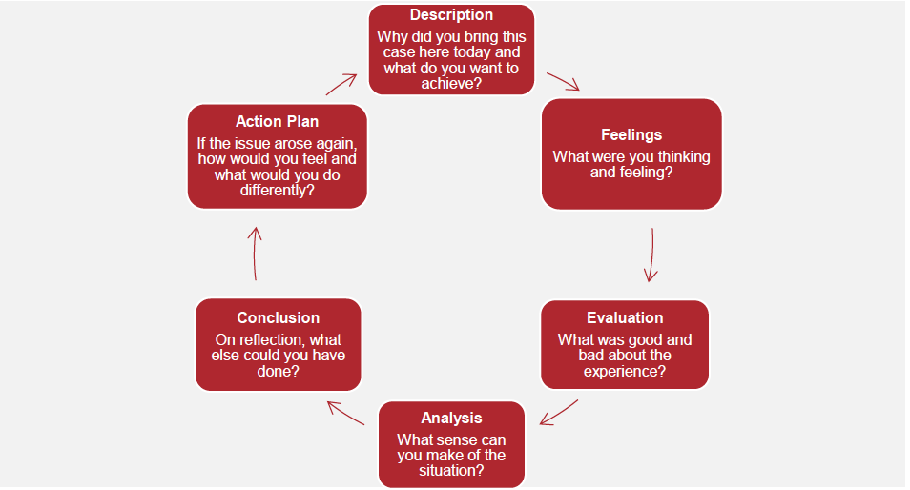

Clinical supervision competency
The National Clinical Supervision Competency Resource (Health Workforce Australia 2014) outlines the core competencies of a clinical supervisor. MCH Services and nurses should ensure their selected clinical supervisor meets these core competencies, whether the clinical supervisor is external or internal to the MCH workforce. MCH Services may opt to build capacity from within, by supporting a MCH nurse to undertake clinical supervision training. Any clinical supervisor training of the MCH workforce must assist participants to meet the three domains of the resource:
- clinical supervision
- safety and quality in clinical supervision
- organisation.
If the clinical supervision is in a group setting, it is important that the clinical supervisor has the attributes and skills to facilitate groups. Some clinical supervision training providers include a group clinical supervision modality to develop participants’ group facilitation skills.
The MCH workforce can use the associated Clinical Supervision Skills Review Tool to assist the internal clinical supervisor to evaluate their skills and identify areas that my need further improvement. The tool is aimed at clinical supervisors with foundational or intermediate skills.

Monitoring and evaluation
Evaluation and monitoring is an important element of the guidelines and will be conducted by both the department and MCH services. The department will evaluate the implementation of the clinical supervision guidelines’ intended outcome of increased capacity and confidence of Enhanced MCH nurses to support additional needs families through clinical supervision. The monitoring and evaluation themes centre on:
- proportion of Enhanced MCH nurses participating in clinical supervision
- level of confidence of Enhanced MCH nurses following participation in clinical supervision.

MCH Coordinators will be responsible for ensuring:
- all Enhanced MCH nurses have a clinical supervisor as evidenced by an active clinical supervision agreement within three months of commencing employment (see Appendix 1)
- session feedback and quarterly evaluation forms part of the clinical supervision agreement (see Appendix 2 and 3)
- clinical supervision agreements are reviewed on an annual basis
- quarterly reports from clinical supervisors detailing any ongoing themes requiring further support are actioned
- participation in the departments monitoring of clinical supervision, by providing the number of Enhanced MCH nurses participating in clinical supervision and the number of clinical supervision agreements in place.
Clinical Supervisors will be responsible for ensuring:
- records of session attendance and key themes and outcomes are documented and stored as per the clinical supervision agreement (see Appendix 4)
- session feedback informs planning of future sessions
- quarterly evaluation reports of progress against agreed goals detailed in the clinical supervision agreement are provided to the MCH Coordinator.
The department will be responsible for ensuring:
- clinical supervision participation and level of confidence is monitored through a survey of Enhanced MCH nurses
- clinical supervision participation data from MCH Coordinators is analysed.
The department will survey Enhanced MCH nurses prior to implementation of the clinical supervision guidelines and then annually, covering:
- proportion of Enhanced MCH nurses that report that they are offered and attend individual, facilitated group or external clinical supervision
- proportion of Enhanced MCH nurses that report that they undertake reflective practice during clinical supervision
- proportion of Enhanced MCH nurses that report improvements in confidence and capacity to address the complex needs of clients.
Additionally the department will measure program success through the annual Workforce Report completed by the MCH service which will include the:
- percentage of Enhanced MCH nurses engaged in clinical supervision as per attendance log
- percentage of Enhanced MCH nurses with an active clinical supervision agreement in place.

References
Australian Clinical Supervision Association 2015, Definitions of Clinical Supervision: for clinical supervisees and supervisors
Australian College of Nursing 2016, Clinical Supervision Background Paper
Australian Health Ministers' Advisory Council 2011, National Framework for Universal Child and Family Health Services
Australian Health Practitioner Regulation Agency 2014, Guidelines for Mandatory Notifications
Bond, M & Holland, S 1998, Skills of Clinical Supervision for Nurses, Open University Press, Birmingham, UK
Boyd, E.M & Fales, A.W. 1983 ‘Reflective learning: key to learning from experience’, Journal of Humanistic Psychology, vol. 23, no. 2, pp. 99-117
Brunero, S. & Stein-Parbury, J. 2008 ‘The effectiveness of clinical supervision in nursing: an evidence based literature view’, Australian Journal of Advanced Nursing, vol. 25, no. 3, pp. 86-94
Butterworth, T., and Faugier, J. 1992, Clinical Supervision and Mentorship In Nursing. London: Chapman and Hall
Child and Family Health Nurses Association (NSW) Inc 2003, Guidelines for Clinical Supervision for Child and Family Health Nurses
Children’s Health Queensland Hospital and Health Service 2015, Procedure: Clinical Supervision for Registered Nurses - In Child and Youth Community Health Services (CYCHS)
Consedine, M 2001 ‘Using Role Theory in Clinical Supervision’, Australian & New Zealand Psychodrama Association Journal, vol. 10, pp. 37-49
Department of Health and Human Services 2015, The Clinical Supervision Skills Review Tool
Eastern Health 2017, Clinical Supervision for Mental Health Nurses Practice Guideline
Grant, J., Mitchell., C & Cuthbertson, L. 2017, National Standards of Practice for Maternal, Child and Family Health Nursing Practice in Australia, Adelaide, Flinders Press
Hawkins, P. & Shohet, R. 1989, Supervision in the Helping Professions. An individual, group and organizational approach, Milton Keynes: Open University Press
Health Education and Training Institute 2013, The Superguide: A Supervision Continuum for Nurses and Midwives
Health Education and Training Institute 2015, NSW Health Clinical Supervision Framework
Health Workforce Australia 2014, National Clinical Supervision Competency Resource
International Confederation of Midwives 2014, International Code of Ethics for Midwives, Netherlands International Council of Nurses 2012, The ICN Code of Ethics for Nurses
Latrobe University 2017, Reflective practices in health: models of reflection, viewed 3 January 2018, <http://latrobe.libguides.com/reflectivepractice/models>.
Nursing and Midwifery Board of Australia 2016, Registered nurse standards for practice
Nursing and Midwifery Board of Australia 2006, National competency standards for the midwife
Nursing and Midwifery Board of Australia 2008, Code of Professional Conduct for Nurses in Australia Nursing and Midwifery Board of Australia 2008, Code of Professional Conduct for Midwives in Australia
Proctor, B. 1987, ‘Supervision: A co-operative exercise in accountability’ in M. Marken and M. Payne (eds.) Enabling and Ensuring. Supervision in practice, National Youth Bureau, Leicester
Schön, D. A 1983, The reflective practitioner: how professionals think in action. New York: Basic Books
Tomlin, A. & Scott Heller, S. 2016, ‘Measurement Development in Reflective Supervision: History, Methods, and Next Steps’, Zero to Three Journal: Measuring and Building Reflective Capacity, vol. 37, no. 2, pp. 4-12
Winstanley, J & White, E 2003, ‘Clinical supervision: models, measures and best practice’, Nurse Researcher, vol.10, no. 4, pp. 7-38

Appendix 1: Text-equivalent descriptions of figures

Figure 1: Proctor’s Model of Supervision
The figure comprises a circle divided into three segments labelled ‘Formative’, ‘Normative’ and ‘Restorative’.

Figure 2: Operational supervision vs clinical supervision
The figure comprises two columns. The left-hand column is headed ‘Operational supervision’, and contains the following components:
- Includes clinical oversight, compliance and professional, managerial, educational and administrative supervision
- Largely supervisor driven and supervisor evaluated
- Performance factors are prominent
The right-hand column is headed ‘Clinical supervision’, and contains the following components:
- Confidential, facilitated reflection on professional practice
- Supervisee driven
- Working agreement is in place
- Evaluation is negotiated

Figure 3: Reflective cycle
The figure comprises six boxes arranged in a circle with arrows pointing between them.
- Description
- Why did you bring this case here today and what do you want to achieve?
- Feelings
- What were you thinking and feeling?
- Evaluation
- What was good and bad about the experience?
- Analysis
- What sense can you make of the situation?
- Conclusion
- On reflection, what else could you have done?
- Action plan
- If the issue arose again, how would you feel and what would you do differently?

Appendix 2: Clinical supervision agreement example
Adapted from: Health Education and Training Institute 2013, The superguide: a supervision continuum for nurses and midwives
Information required | Field to complete
Date of agreement:
Supervisee:
Supervisor:
MCH Coordinator:

Clinical supervision will address the following areas
Areas to address

Clinical supervision will take the following form and frequency
(e.g. individual or group)
Form and frequency of supervision

Confidentiality
The content of clinical supervision meetings is confidential between the parties. The exemptions of confidentiality are outlined in the Clinical Supervision Guidelines for Enhanced Maternal and Child Health Program.
Should information need to be shared, the supervisor will advise the supervisee in advance, including what will be shared, with whom and for what purpose.
Other confidentiality issues to consider

Record of clinical supervision
Information required | Field to complete
Who will record it?
Where will records be kept?
Who has access to this information?
What will happen to the clinical supervision notes when:
The supervisee leaves their position
The supervisor leaves their position
Additional information

Clinical supervision meetings

How meetings will be conducted
Information required | Field to complete
The supervisee will prepare by:
The supervisor will prepare by:
If a meeting needs to be rescheduled:

Considerations for monitoring and evaluation
Information required | Field to complete
Clinical supervision session feedback will be sought in the following format:
Evaluation of clinical supervision effectiveness will be sought quarterly in the following format:

Other considerations
The details of this agreement can be modified at any time when agreed by all parties.
Details of other considerations:

Signatures
A copy of this agreement will be given to the MCH coordinator or line manager for their records.
Information required | Field to complete
Supervisee signed:
Name:
Date:
Supervisor signed:
Name:
Date:

Appendix 3: Example of clinical supervision session feedback template
Source: Health Education and Training Institute 2013, The superguide: a supervision continuum for nurses and midwives

Clinical supervision session feedback
Information required | Field to complete
Name (optional):
Date:
Do you have an agreed documented clinical supervision agreement with your supervisor? | Yes / no
Are your supervision goals and objectives being met? | Yes / no
In what ways are / aren’t these goals and objectives being met?
What was the most useful aspects of your supervision today?
What expectations were not met from your supervision today?
Do you have any additional comments about your supervision?

Appendix 4: Clinical supervision quarterly evaluation example
Source: SA Health 2014, Allied health clinical supervision framework

Evaluation form
Information required | Field to complete
Name of supervisor:
Name of supervisee:
Date:

Quality of the supervision process
Rating scale: 1. Almost never; 2. Occasionally; 3. Often; 4. Almost always
Evaluation question | Supervisor rating | Supervisee rating
1. We negotiated a mutually acceptable clinical supervision agreement identifying goals, roles and responsibilities of both parties
2. The supervisor/ee fulfilled his/her commitments as specified in the clinical supervision agreement
3. The supervisor/ee worked together to formulate supervision questions and topics to discuss as required as reliable
4. The supervisor/ee kept a reflective journal to assist in the supervision process and the development of reflective practice
5. The supervisor/ee communicated sensitivity towards cultural and ideological differences relevant to clinical practice
6. The supervisor/ee respected confidentiality issues, as outlined in the Clinical supervision guidelines for enhanced maternal and child health program
7. The supervisor/ee sought feedback from supervisee/or about satisfaction with supervision

Outcomes of supervision
Rating scale: 1. Almost never; 2. Occasionally; 3. Often; 4. Almost always
Evaluation question | Supervisor rating | Supervisee rating
8. Supervision improved supervisee clinical skills, knowledge, and attitudes relating to clinical practice
9. Supervision increased supervisee confidence as a practitioner
10. Supervision increased supervisee knowledge of ethical issues in practice
11. Supervision increased supervisee knowledge of relevant local, state and national policies and procedures
12. Supervisee feels more enthusiastic about work as a result of the supervision experience
13. Supervision motivated the supervisee to work on developing clinical skills

Appendix 5: Clinical supervision group attendance record example
Source: Women, Youth and Children Community Health Programs 2017, WYCCHP clinical reflective practice framework for nurses

Clinical supervision group record of attendance
Information required | Field to complete
Date and time of session:
Venue:
Name of clinical supervisor:
Participant names:

Signatures:
Information required | Field to complete
Key themes and outcomes:
Clinical supervisor’s signature:
Date:

Storage:
MCH coordinators and participants may request a copy of this record. The clinical supervisor is otherwise responsible for the secure storage of Clinical Supervision records.

